Project Proposal

On

**Mobile Shop Management System**

Rupesh Thapa

00175010

Computing Project

Level 5 in Computing

Softwarica College of IT & E-commerce

Kathmandu, Nepal

04/03/2019

Submitted To: Niman Maharjan

# **Chapter 1: Introduction**

# **Project Introduction**

The technology has advanced rapidly from past few years and people want to do the daily task faster and easier. People want easy and stress less life. They don’t want to stand and wait on a long queue to complete their task. Technology such as smartphone, computer, internet and software systems help people make task simpler and easier. So, the software systems or application save time and the proposed system is Mobile shop Management System where employee use it to make task easier and provide good service to customers.

# **Justification for the project**

## **Background of the project**

Mobile shop management system is the desktop application for a mobile shop where employee use it to keep the stock records, customer and invoice records as well as employee information.

In this, desktop application employee is the user as all the tasks are performed by them and application perform overall works of the shop. It also records customer information and their invoice information. Employee need to register and logged in for using the system.

The system is a user-friendly application and user can easily understand to use it. User can record, update, delete and search the data easily through this application. This application is developed using C-sharp programming language and SQL Server for recording data as back end database.

## **Problem Statement**

The old system is paper based, and they store their records manually. It is time consuming to search any record. Wastages of resources to store old record books. When a customer requests for the model, employee might have to check availability of the stock in storage physically. The current system is outdated and old.

The proposed system is expected to overcome all these problems and makes the day to day business or work easier than now. It will make the system more secure reduce the use of paper and help creating invoice as well.

# **Description of the project**

## **Features of the system**

The system consists of following features which makes the work of shop faster, reliable and easier.

* Employee can add employee, customer and invoice record to the system:

The system allows user/employee to register and add their details and add customer, invoice details as well as stock records.

* Employee can update and remove the recorded details:

The system allow user to remove the details as well as update according to the requirements.

* Bills can be generated using this system for customers:

This system allows an employee to create invoice for customers and store it as well.

* Employee can search, record and view information:

Employee can track the stock details as well as search all the information of employee and customer.

* Owner can keep track of all details:

The owner can usually keep track of profit and loss through invoice and stock records.

# **Overview of the project**

# **Chapter 2: Scope of the project**

# **Scope**

Mobile shop management system is the desktop system for employee of the shop. It helps the employee to easily create an invoice of a customer rather than paper-based bill. The system also helps keeping track of shop transaction on daily basis. All the data are stored on a secure database. It provides user friendly interface for employees which reduces paper work. It will make functioning of store faster and will reduce human error. The proposed system is more efficient than the existing system.

# **Limitation**

The limitation of proposed system are as follows:

* End user should have the basic knowledge of the computers.
* This system will only available till the system on which it is installed is running.
* The system is not portable as it is a standalone application running on single system with no shared database.

# **Aims**

The main aim of the project is to create a digital system and remove the old paper based working environment. It also aims to create efficient system than existing one, to reduce human error and to create a faster functioning system to reduce time and cost of the organization or shop. It also aims reducing time and cost with application capable of securing data.

# **Objectives**

The objectives of proposed system are as follows:

* It will reduce human error and make functioning of store faster.
* It will provide user friendly interface for employees which reduces paper work.
* The system is more efficient than the existing system.
* It helps creating record, updating existing data and removing unnecessary data.

# **Chapter 3: Development Methodology**

# **Waterfall Model**

For, the development of this software, I have applied waterfall model. Waterfall model is a traditional approach where the process is carried out step wise after the completion of one step another one is carried out. The system proposed is a small project and all the objectives are clear so, waterfall model is best approach. Waterfall model has six steps which is carried out one at a time. The waterfall model is a sequential design process in which progress is seen as flowing steadily downwards (like a waterfall) through the phases of Requirement Analysis, Design, Implementation, Testing, Deployment and Maintenance. (ToolsQA, 2019)

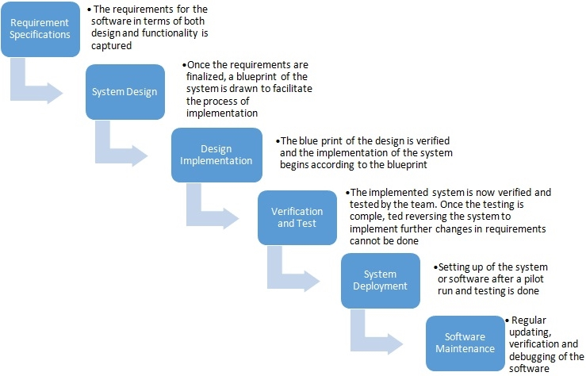

**Figure 1: Waterfall Model**

In, the first stage requirements of the system are gathered and understand what needs to be design. Then from the reference of this stage, design is made of the system. From design stage the system is implemented using programming language and once implemented the testing of the system is carried out to find any error or bug. Then the system is deployed and maintained regularly with updates.

# **Design Pattern**

A design pattern is a general repeatable solution to a commonly occurring problem in software design. Design pattern are battle tested solution but not a complete one. Design patterns can speed of the development process by providing tested, proven development paradigms. I am using MVC (Model View Controller) design pattern in this project. (Source Making, 2019) In, MVC pattern codes are separated according to their nature in system.

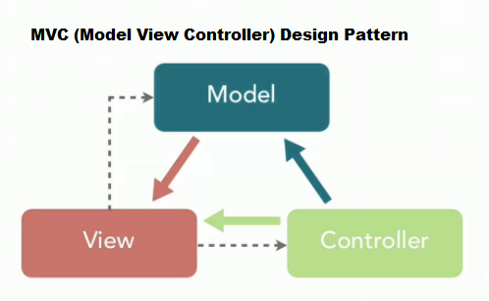

**Model:** Model controls the data related logic that user work with. It is the central component of the pattern. It is the applications dynamic data structure, independent of the user interface. It directly manages the data and logic of the application.

**View:** It handles the User interface part of the system. It represents information for user to interact with the system.

**Controller:** It acts as an intermediary between model and view to process incoming request. The controller responds to the user input and perform interaction on the data model objects.

# **System Architecture**

System architecture is the structural design of systems and it is a conceptual model. System architecture serves as the blueprint for both the system and the project developing it, defining the work assignments that must be carried out by design and implementation teams. (Carnegie Mellon University, 2019) It shows the relationship between the system. For, this project I will be using 3-tier architecture.

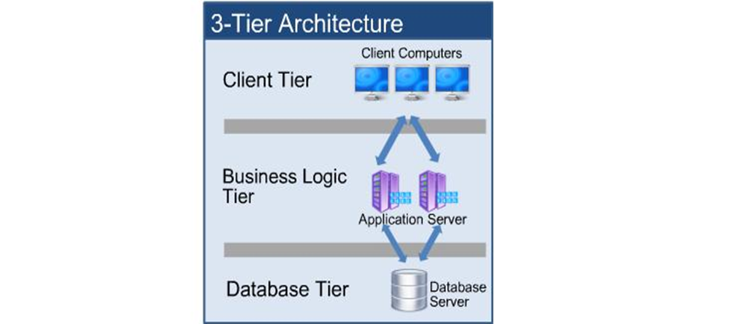

**Database Tier:** It is the database server. In this layer data and information are stored and from here data are retrieved. This is independent of application layer and business logic.

**Application Tier:** This is also known as logical or application layer. It controls over the functionality of the application. In this layer all the logical operations are operated. It helps communicating between client and database.

**Client Tier:** This layer displays information to the user through interface. It displays results to client.

# **Chapter 4: Project Plan Work Breakdown Structure**

# **Work Breakdown Structure**

WBS is a key project deliverable that organizes the team’s work into manageable sections. The work breakdown structure visually defines the scope into manageable chunks that a project team can understand, as each level of the work breakdown structure provides further definition and detail. This method is used by most of company to complete project in time. The project team creates the project work breakdown structure by identifying the major functional deliverables and subdividing those deliverables into smaller systems and sub-deliverables. These sub-deliverables are further decomposed until a single person can be assigned. (Work breakdown structure, 2019)

Mobile Shop Management system

Final Report

White Box Testing

Black Box Testing

User Manual

Integration Testing

Unit Testing

Build Database

Coding

Feasibility study

Structural Model

Behavioral Model

UI Design

Database Design

Monitoring

Final Document

Design

Implementation

Proposal

Analysis

Testing

Scope

Gathering Requirements

Planning

Use Case

Class Diagram

|  |  |  |
| --- | --- | --- |
| **WBS** | **TASK NAME** | **NUM OF DAYS** |
| **0** | **Mobile Shop Management System** | **110** |
| **1**  1.1  1.2  1.3 | **PROJECT PROPOSAL**  Scope  Planning  Monitoring | **16**  5  8  3 |
| **2**  2.1  2.2  2.3  2.4 | **ANALYSIS**  Feasibility Study  Gathering Requirements  Use Case  Class Diagram | **29**  8  8  6  7 |
| **3**  3.1  3.2  3.3  3.4 | **DESIGN**  Structural Model  Behavioral Model  UI Design  Database Design | **26**  6  6  7  7 |
| **4**  4.1  4.2 | **IMPLEMENTATION**  Build Database  Coding | **21**  5  16 |
| **5**  5.1  5.2  5.3  5.4 | **TESTING**  Unit Testing  Integration Testing  Black Box Testing  White Box Testing | **7**  2  1  2  2 |
| **6**  6.1  6.2 | **FINAL DOCUMENTATION**  User Manual  Final Report | **11**  5  6 |

# **Milestones**

|  |  |  |
| --- | --- | --- |
| **TITLE** | **START DATE** | **DEADLINE** |
| 1. **Proposal** | **25TH March 2019** | **9th April 2019** |
| 1.1 Scope | 25th March 2019 | 29th March 2019 |
| 1.2 Planning | 30th March 2019 | 6th April 2019 |
| 1.3 Monitoring | 7th April 2019 | 9th April 2019 |
| 1. **Analysis** | **10th April 2019** | **8th May 2019** |
| 2.1 Feasibility Study | 10th April 2019 | 17th April 2019 |
| 2.2 Gathering Requirements | 18th April 2019 | 25th April 2019 |
| 2.3 Use Case | 26th April 2019 | 1st May 2019 |
| 2.4 Class Diagram | 2nd May 2019 | 8th May 2019 |
| 1. **Design** | **9th May 2019** | **3rd June 2019** |
| 3.1 Structural Model | 9th May 2019 | 14th May 2019 |
| 3.2 Behavioral Model | 15th May 2019 | 20th May 2019 |
| 3.3 UI Design | 21st May 2019 | 27th May 2019 |
| 3.4 Database Design | 28th May 2019 | 3rd June 2019 |
| 1. **Implementation** | **4th June 2019** | **24th June 2019** |
| 4.1 Build Database | 4th June 2019 | 8th June 2019 |
| 4.2 Coding | 9th June 2019 | 24th June 2019 |
| 1. **Testing** | **25th June 2019** | **1st July 2019** |
| 5.1 Unit Testing | 25th June 2019 | 26th June 2019 |
| 5.2 Integration Testing | 27th June 2019 | 27th June 2019 |
| 5.3 Black Box Testing | 28th June 2019 | 29th June 2019 |
| 5.4 White Box Testing | 30th June 2019 | 1st July 2019 |
| 1. **Final Documentation** | **2nd July 2019** | **12th July 2019** |
| 6.1 User Manual | 2nd July 2019 | 6th July 2019 |
| 6.2 Final Report | 7th July 2019 | 12th July 2019 |

# **Scheduling**

## **Time Estimation Table**

## **Gantt chart**

# **Chapter 5: Risk Management**

Software development is activity that uses a variety of technological advancements and requires high levels of knowledge. The success of a software development project depends quite heavily on the amount of risk that corresponds to each project activity. To achieve a successful outcome, project leadership must identify, assess, prioritize, and manage all the major risks. Risk Management is the process of identify, analyzing of risk factor in project. It should be part of planning process to figure out risk in the project and control risk for future events. (CAST, 2019)

The list of possible risks for the project are as follows:

* Natural Disaster
* Hard Disk Failure
* Requirement does not meet
* Equipment Failure
* Server Failure
* Lack of Skilled Manpower
* Insufficient Resources

The risks impact is calculated, and solution is given below through likelihood and consequences table of a risks.

**Impact = Likelihood * Consequence**

Risk Likelihood values are shown as follows

|  |  |
| --- | --- |
| **Likelihood** | **Value** |
| Low | 1 |
| Medium | 2 |
| High | 3 |

Risk Consequence values are shown below

|  |  |
| --- | --- |
| **Consequence** | **Value** |
| Very low | 1 |
| Low | 2 |
| Medium | 3 |
| High | 4 |
| Very High | 5 |

Risk Consequences values are shown below:

|  |  |  |  |  |  |
| --- | --- | --- | --- | --- | --- |
| **S.NO** | **Risks** | **Likelihood** | **Consequences** | **Impact** | **Solution** |
| 1 | Natural Disaster | 1 | 4 | 4 | Backup Plan |
| 2 | Hard Disk Failure | 1 | 5 | 5 | Data should be backed up for example: cloud storage e.t.c. |
| 3 | Requirement  Does not meet | 2 | 4 | 8 | Requirement analysis should be properly done. |
| 4 | Equipment Failure | 2 | 4 | 8 | System should be checked time to time and regular maintenance. |
| 5 | Server Failure | 1 | 5 | 5 | Proper backup of data and should be kept securely. |
| 6 | Lack of Skilled Manpower | 1 | 3 | 3 | Proper training should be provided. |
| 7 | Insufficient Resources | 2 | 3 | 6 | All required resources should made available in time. |

# **Chapter 6: Configuration Management**

Configuration management refers to the system or term which tracks hardware, software and related information of the system. Configuration managementfocuses on establishing and maintaining consistency of a product's performance, and its functional and physical attributes with its requirements, design, and operational information throughout its life. It can be used by management and engineers to check which components have been changed and why, ensuring an audit trail of changes done to the system. (C2S Consulting group, 2019)

Version controls are the category of software tools that helps to manage source code for the software team. It allows you to revert selected files back to a previous state, revert the entire project back to a previous state, compare changes over time, see who last modified something that might be causing a problem, who introduced an issue and when, and more. Using a Version Control System also generally means that if you screw things up or lose files, you can easily recover.

Git is one of the Distributed Version Control Systems where clients don’t just check out the latest snapshot of the files; rather, they fully mirror the repository, including its full history. Thus, if any server dies, and these systems were collaborating via that server, any of the client repositories can be copied back up to the server to restore it. Every clone is really a full backup of all the data.

Git id for this project is: <https://github.com/liteyagamee>